My response:
Hi Himansu,
This makes 100% sense, and it’s actually a much cleaner problem to solve than a generic public scraper!
Here is the exact breakdown of how we solve this for you:
1. Private Latency (Beating the 30-Person Slack Group):
Public/shared Slack bots delay notifications because they process group queues. By running a dedicated private Python polling engine solely for you, you skip that delay entirely. The moment a resale/relisted ticket hits Ticketmaster, AXS, or See Tickets, you get an instant 1-to-1 alert straight to your phone via WhatsApp/SMS.
2. Deep-Link 1-Click Checkout:
Major ticketing sites lock checkout behind CAPTCHAs, so auto-inserting into a cart across external sessions can trigger bot blocks. The ultimate fast solution: We generate a direct deep-link pre-filtered to your exact section (e.g., Standing Only) and max price. You tap the WhatsApp alert, the link opens directly in your browser with your filters pre-applied, and you check out in seconds.
3. Multi-Event Preset Dashboard:
A lean web dashboard where you can add/edit 10–20 active events, set specific section filters (e.g., Section 110 / Standing), and cap max price per event.
Should I drop the scope PDF over to you here on WhatsApp or via email once it's ready?
Best,
Ahmed (edited)
Client Question:
What if going forwards once our system is built, these websites build extra things/security to stop what we are doing....but theres a different way around it....
My Response:
That is a super smart question to ask, and honestly, anyone building custom scrapers who tells you sites never update their security is lying to you!
1. 30-Day Post-Launch Warranty (Included Free):
Once the system goes live, you get 30 days of full technical coverage. If Ticketmaster or AXS tweak their layout, update anti-bot rules, or break selectors during those 30 days, we fix and adapt the engine for free so your initial build stays rock-solid.
2. Built-in Anti-Bot Architecture From Day 1:
We build the core system using rotating residential proxies and realistic headers from day one, meaning simple security tweaks on their end won't affect your engine in the first place.
3. Long-Term Peace of Mind (Optional):
After the 30-day warranty, if a ticketing site makes major anti-bot overhauls down the line, we can either handle one-off updates as needed or set you up on a light monthly maintenance slot (£99/mo) to keep your proxy rotation active and engine updated continuously.
Bottom line: You won't be left hanging at launch, we’ll make sure the system is fully dialed in and beating the competition before anything else!
Sending over the written scope doc now so you can review everything. Sound good?
Best,
Ahmed
Remember to add possibility of making it link with my multilogin on my phone or the possibility of being signed into say 10 google profiles on my phone so I can be logged into 10 different ticketmaster accounts at the same time. Ideally the multilogin integration would be better as my ips on them are set and would have individual ips constantly which doesnt leave a fingerprint with ticketmaster to flag an account uphttps://www.ticketmaster.co.uk/event/370064A8CEFC63DD https://www.ticketmaster.co.uk/event/370064A8CEFC63DD https://www.ticketmaster.co.uk/the-cure-at-live-from-wythenshawe-park-manchester-21-08-2026/event/1F00633D6C0E2F4F https://www.ticketmaster.co.uk/event/1F0064659AFC3197 https://tickets.royalalberthall.com/syos2/performance/102693Filter to set on these will be 2 or more tickets. Arena A & F. Normal tickets not VIPAs for the notification of a ticket thats become available/dropped....I'll get a notification on my phone that pops up at the top right? Then 1 click straight in?
Example of how the notification pops up...section etc listed too
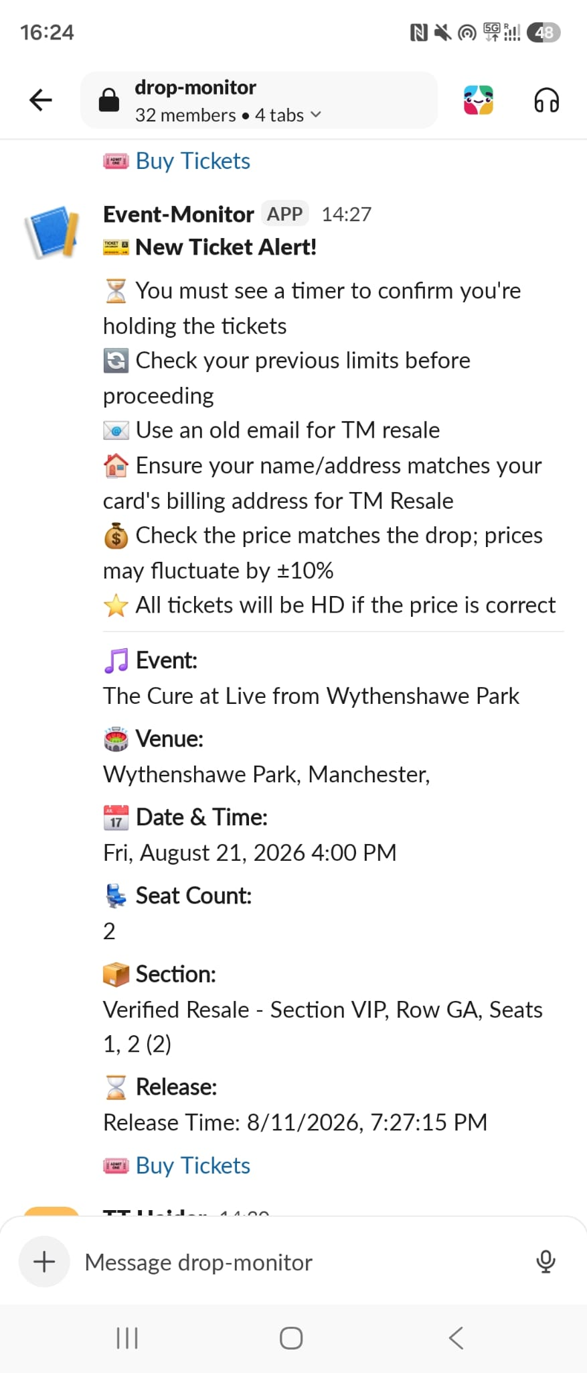

Core Architectural Deliverables:
1. PWA Central Dashboard: o Mobile-first responsive Progressive Web App accessible via desktop and mobile devices. o Centralized dashboard UI for real-time ticket monitoring and alert notifications.
2. Multi-Platform Event Monitoring Engine: o Automated monitoring integration for specified ticketing platforms, including: Ticketmaster (UK & Worldwide regional domains) AXS.com SeeTickets Gigs and Tours Royal Albert Hall ticketing portal Additional custom target event URLs as configured by the admin interface.
3. MultiLogin / Mobile Profile Integration Framework: o API/Local connector interface to integrate with Client's MultiLogin application profiles and sticky IP proxy setups. o Architecture engineered to allow individual IP/fingerprint isolation per session (e.g., maintaining up to 10+ concurrent isolated account profiles on mobile/desktop without triggering anti-bot fingerprinting flags)

[6:22 PM]
I know this is very poorly documented, but if you can not work with this do let me know I will do something about it.

